Rate My Slumlord

Sprint Review Report
Sprint 4
Version 1.2
08/01/2019

Matthew Gabrin, John Held, Ryan Gabrin
Software Engineer

Prepared for
CS 1530 Software Engineering
Summer 2019
University of Pittsburgh

Revision History

Date | Description | Author | Comments
07/25/2019 | Version 1.1 | Gabrin, Gabrin, Held | Initial Revision
07/28/2019 | Version 1.2 | Gabrin, Gabrin, Held | Burndown and Velocity charts added, final additions to Specific Goals stories made.

Document Approval

The following Software Requirements Specification has been accepted and approved by the following:
Signature | Printed Name | Title | Date
 | Ryan Gabrin | Software Eng. | 08/01/2019
 | Matthew Gabrin | Software Eng. | 08/01/2019
 | John Held | Software Eng. | 08/01/2019

Table of Contents

Revision History ii
Document Approval ii
1. Introduction 1
2. Specific Goals 1
3. AnalTICS 6
4. CONCLUSION 7

1. Introduction
Sprint 4 was focused on finalizing all integration between the graphical user interface (GUI), database, and API designed for the system. With the development of each piece completed in Sprint 1, Sprint 2, and Sprint 3, this iteration was used to apply the necessary adjustments to provide data to the required attributes and properly set up the interactive attributes (buttons, forms, etc.) for the user to carry out all desired functionalities. Also, this sprint focused on QA and testing of the final product to ensure that no bugs were persisting that would inhibit the end user experience. Numerous JUnit tests were developed with the integration of the tool Selenium, a front-end automation software that allows a user to carry out numerous actions that a user themselves could attempt, providing the output from those actions and verifying that it matches that which is to be expected. These tests ensured that the program properly executed many of its main functionalities as desired for the final product. As the prior three iterations were successful in carrying out all stories assigned to them, there were only a total of 9 stories and 21 story points assigned to this sprint. These were all able to be completed prior to the product’s release and demo to the final customer on August 1st.
This sprint was difficult in that it required the most code refactoring of any sprint thus far and was the main integration point for all code written by each individual group member. As we each specialized in our own aspects of the project - namely the database, front end GUI, and middleware – this integration required quite a bit of communication and open collaboration between group member. Co-location was key in this scenario, as quick answers to questions were necessary to maintain a workflow and avoid wasting time trying to adjust a feature to meet the requirements to be fully implemented. Ultimately, the sprint was successful and the team was able to provide a functional final product as desired by the user.

2. Specific Goals
Below are all stories assigned to Sprint 4 with further clarification regarding their individual progress and purpose.

2.1 Story Name & Number
“Spring – login admin/Moderator” – Story 4.1.1
2.1.1 Story Description:
This story focuses on finalizing the login capabilities of an admin or moderator to the system. This ensured that only those with credentials that have been pre-approved are capable of gaining access to the system in that heightened permissions state.
2.1.2 Story Acceptance Criterion
This story will be considered complete when only valid username/password pairs will allow a user to log in to the system and will assign the proper permissions value to them according to their credentials.
2.1.3 Story Dependencies
This story is not dependent on any other stories.
2.1.4 Story Challenges

2.1.5 Story Assigned to
Matthew Gabrin
2.1.6 Story Points
4 points were assigned to this story.
2.1.7 Status: Completed or not
Completed

2.2 Story Name & Number
“DB – Populate DB with (“Real”) Data” – Story 4.1.2
2.2.1 Story Description:
This story focuses on generating data to be used in the demonstration and testing of the system. This data will range from login credentials to user reviews and all other potentially data necessary for the functionality of the system.
2.2.2 Story Acceptance Criterion
This story will be considered complete when all tables generated in the database contain valid data that can be used for JUnit testing and the final demonstration.
2.2.3 Story Dependencies
This story is not dependent on any other stories.
2.2.4 Story Challenges
No challenges.
2.2.5 Story Assigned to
JP Held
2.2.6 Story Points
6 points were assigned to this story.
2.2.7 Status: Completed or not
Completed

2.3 Story Name & Number
“Backend – Unit Testing to verify DB Integrity” – Story 4.1.3
2.3.1 Story Description:
This story will focus on determining whether or not the database, in its current configuration is protected from injection attacks and other malicious inputs that could disrupt, adjust, or insert data needed by the system.
2.3.2 Story Acceptance Criterion
This story will be considered complete when the database is protected from attacks made through the user GUI and potentially malicious input strategies aimed at reaching the database.
2.3.3 Story Dependencies
This story is dependent upon 4.1.2, tasked with populating the database with valid data so that the user can properly test using malicious data to see its affect on the system, if any.
2.3.4 Story Challenges
No challenges.
2.3.5 Story Assigned to
JP Held
2.3.6 Story Points
2 points were to this story.
2.3.7 Status: Completed or not
Completed

2.4 Story Name & Number
“React – finishing touches” – Story 4.1.4
2.4.1 Story Description:
This story will focus on cleaning up any remaining GUI functionality and integration with the middleware provided by the work done in Sprint 3. This includes adjusting any input fields to properly interface with the API connections and standardizing all styling across any updated pages.

2.4.2 Story Acceptance Criterion
This story will be considered complete when all pages are properly
2.4.3 Story Dependencies
This story is dependent upon Story 4.1.1, finishing the login functionality for admin/moderator and 4.1.2, populating the database with viable data to be used for testing.
2.4.4 Story Challenges

2.4.5 Story Assigned to
Matthew Gabrin
2.4.6 Story Points
4 points were assigned to this story.
2.4.7 Status: Completed or not
Completed

2.5 Story Name & Number
“JUnit/Selenium testing – adding a review” – Story 4.1.5
2.5.1 Story Description:
This story will focus on establishing JUnit tests necessary to ensure that reviews are able to be added with appropriate parameters and proceed to the next step necessary to be displayed.
2.5.2 Story Acceptance Criterion
This story will be considered complete when all JUnit tests are green and passing.
2.5.3 Story Dependencies
This story is not dependent on any other stories.
2.5.4 Story Challenges
No challenges for this story.
2.5.5 Story Assigned to
Ryan Gabrin
2.5.6 Story Points
2 points were assigned to this story.
2.5.7 Status: Completed or not
Completed.

2.6 Story Name & Number
“JUnit/Selenium testing – liking/disliking reviews” - Story 4.1.6
2.6.1 Story Description:
This story will focus on establishing JUnit tests necessary to ensure that reviews are able to be liked and disliked, and that this information is saved in the database to be viewed by other users when seeing the given review. This is important in that it ensures our users are able to get feedback on the reliability of a review and if it matches the experience of other tenants of a given landlord.
2.6.2 Story Acceptance Criterion
This story will be considered complete when all JUnit tests are green and passing.
2.6.3 Story Dependencies
This story is not dependent on any other stories.
2.7.4 Story Challenges
No challenges for this story.
2.6.5 Story Assigned to
Ryan Gabrin
2.6.6 Story Points
1 point was assigned to this story.
2.6.7 Status: Completed or not
Completed

2.7 Story Name & Number
“JUnit/Selenium testing – searching property address” – Story 4.1.7
2.7.1 Story Description:
This story will focus on establishing JUnit tests necessary to ensure that the search box will properly detect addresses input of properties stored within the database in connection with a landlord. This is important in that it will allow users to look up their landlord based on a specific housing unit or property they are looking to sign a lease for should they be unfamiliar with the landlord and unsure of their name.
2.7.2 Story Acceptance Criterion
This story will be considered complete when all JUnit tests are green and passing.
2.7.3 Story Dependencies
This story is not dependent on any other stories.
2.7.4 Story Challenges
No challenges for this story.
2.7.5 Story Assigned to
Ryan Gabrin
2.7.6 Story Points
2 points were assigned to this story.
2.7.7 Status: Completed or not
Completed

2.8 Story Name & Number
“JUnit/Selenium testing – reporting a review” – Story 4.1.8
2.8.1 Story Description:
This story will focus on establishing JUnit tests necessary to ensure that reviews are able to be reported in the event that they do not follow community guidelines or are found to be insincere or untrue. This will be essential to maintain the integrity of the data on our site and is crucial to the accuracy of the reviews being accounted for in all calculations.
2.8.2 Story Acceptance Criterion
This story will be considered complete when all JUnit tests are green and passing.
2.8.3 Story Dependencies
This story is not dependent on any other stories.
2.8.4 Story Challenges
Learning Selenium and all the idiosyncrasies associated.
2.8.5 Story Assigned to
JP Held
2.8.6 Story Points
2 points were assigned to this story.
2.8.7 Status: Completed or not
Completed

2.9 Story Name & Number
“JUnit/Selenium testing – approving/denying a review – Story 4.1.9
2.9.1 Story Description:
This story will focus on establishing JUnit tests necessary to ensure that reviews are able to be approved by a moderator to be released to the public. As this is the main way in which users will gain access to the experiences of prior tenants, this is very important to the operation of our system.
2.9.2 Story Acceptance Criterion
This story will be considered complete when all JUnit tests are green and passing.
2.9.3 Story Dependencies
This story is not dependent on any other stories.
2.9.4 Story Challenges
No challenges for this story.
2.9.5 Story Assigned to
Ryan Gabrin
2.9.6 Story Points
1 point was assigned to this story.
2.9.7 Status: Completed or not
Completed

3. Analytics

3.1 Sprint/Product Burndown Chart

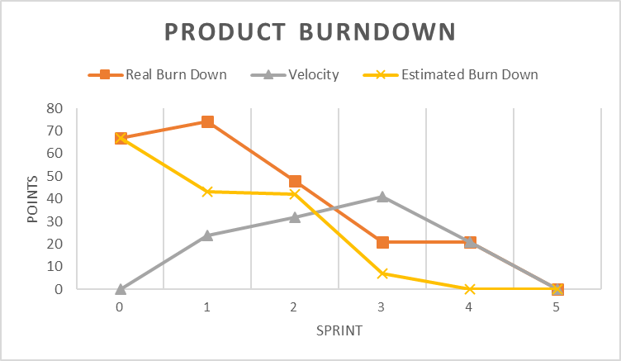

3.2 Sprint Velocity
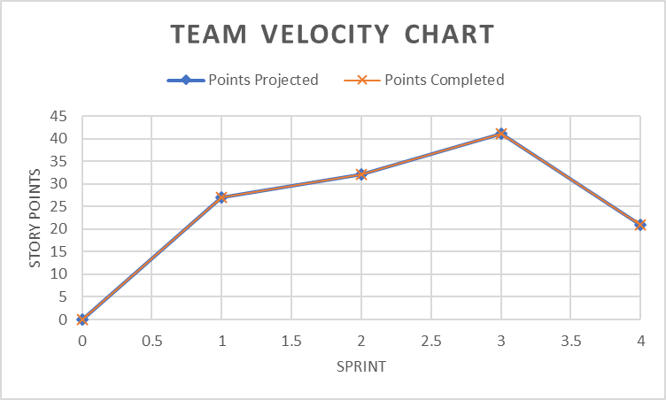

4. Conclusion
This sprint focused on closing out the final integration and testing of the front-end GUI, middleware API, and database developed over the course of the previous four iterations. Once again, as this is the final sprint of this project’s development this was focused on clearing up any functionality defects still present after the prior iterations and ensured that there were no unexpected outputs through various tests using JUnit and Selenium. The project, as a whole, was successful in accomplishing its final goal of providing a user with a hub to find information regarding specific landlords and the qualities that impact their effectiveness in their given role.
As this is the final sprint of this project’s development, the team reflection has found the use of the SCRUM project management model and its methods to facilitate group development to be extremely useful in organizing and maintaining a productive cohesion between members. Looking forward to future projects, we are eager to continuing to implement the strategies and management skills learned throughout the process of completing this project. Most notably, from this process we learned that project integration of various developers’ code should be done frequently and with both developers in the same location at the time of the integration. As our development styles all had their own unique strategies and structures to use for implementing the desired features, it made the end integration slower and more tedious that if we had developed in smaller pieces and done integrations along the way. Also, the team learned the benefits of Test Driven Development (TDD), as this style of programming was not implemented until after much of the GUI code and database setup was already complete. While the tests could not run without these being finished, through the development of tests we realized numerous additional features and functionalities that were highly necessary for the end-product to be successful and this was the main catalyst for any code refactoring and further development. Had we started with these tests in mind, the creation of a proper features in an efficient and effective way would have been easier to accomplish. Overall, though, this SCRUM project model was both effective in exposing these learning opportunities as well as streamlining the development process a great deal, ultimately benefitting the group greatly and proving to be an extremely useful methodology.

